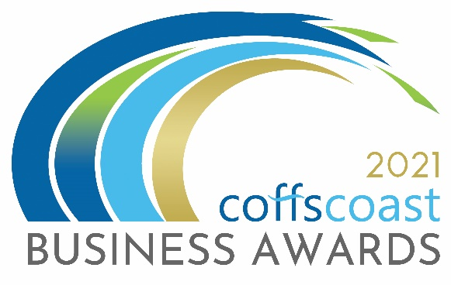
COFFS COAST BUSINESS AWARDS 2021
ENTRY FORM
Category – OUTSTANDING BUSINESS LEADER
*Aligned to Business NSW Awards

Business Details
To be completed by all entrants including those entering into the individual categories
- Trading name:

- Registered ABN:

- How is your business structured?
Choose from drop down list - Choose an item.

- Is your business classified as a not for profit?
Yes ☐ / No ☐

- Main office address:

- Business trading commencement date:

- What industry does the business operate in?
Choose from drop down list - Choose an item.

- Number of employees on payroll in Australia.
Choose from drop down list - Choose an item.

- Is your business primarily business to business or business to consumer?
Choose from drop down list - Choose an item.
- Please provide a 100 word biography for your business to be used for promotional purposes.

- Please indicate the main reason/s you are entering into the Business Awards
- To raise the profile of my business
- To recognise my staff and our achievements
- To build business networks
- To reflect on the goals, strategies and vision that led to the success of your business and to use those insights to drive even greater success in the future.

- Website:
- Twitter:
- Instagram:
- LinkedIn:
- Facebook:

Contact Details:
To be completed by all entrants
Entry Contact Details:
First Name:
Surname:
Position:
Email:
Phone:
Mobile:
Media Contact Details
Tick box if same as above
First Name:
Surname:
Position:
Email:
Phone:
Mobile:

Outstanding Business Leader
The Outstanding Business Leader Award recognises an inspirational business leader aged 36 years or over who has demonstrated a commitment to their workplace, industry and the community through leadership, whilst providing mentorship to others.

Entry criteria
Entrants are required to demonstrate their commitment over the past 12 months to creating a smarter and more inclusive future and to being an outstanding mentor and business leader. To be eligible to enter this category, the individual must have held a senior management or executive level position within their organisation for a minimum of 18 months at the time of entry.

Award eligibility check box
- I am aged 36 years or over at the time of entry.
- I am not an employee, Regional President, State Councillor or Board Member of NSW Business Chamber Limited.

Questions
Entrants full name:
Current job title:
Date of birth:
Name of your organisation or business:
- Provide a brief profile, including your current role and scope of responsibilities. Maximum word count: 200

- Detail the specific activities and initiatives you have undertaken to reshape your workplace, industry or the community to create a smarter and more inclusive future, with examples of how you have used your leadership skills. Maximum word count: 400

- Describe the key challenges you have faced as a business leader and how you overcame them. Maximum word count: 300

- Provide an overview of your five-year goals and strategies for future business growth, detailing how you are working towards achieving them. Maximum word count: 300

- Outline the reasons why you are an outstanding business leader, including the ways in which you provide mentorship to others. Maximum word count: 400

I declare that the information I have provided in this entry form is true and correct at the time of completing this form and that I agree to all conditions of entry listed under the “Conditions of Entry” section of the website. www.coffscoastbusinessawards.com.au
Once you complete this form you should save it on your computer using the file name OUTSTANDING BUSINESS LEADER. Then return to the Coffs Coast Business Awards Website www.coffscoastbusinessawards.com.au
- Go to the application upload section and follow the instructions.
- You will use your email account to upload your completed Entry Forms.
- You must also submit 4 high resolution landscape images in JPG format.
Video options:
To help you in making a video please see the video options section on the upload page
- ALL entries must submit a maximum 20 second video (in MP4 or MOV format). The video clip will be about your business, staff and tell your story as to your reasons for entering the category/s. The video clip and images will be seen by the judges and used as part of a multimedia presentation on the awards night.
- For each category you enter – you must submit a different video clip about your business, staff and tell your story as to your reasons for entering the category.

