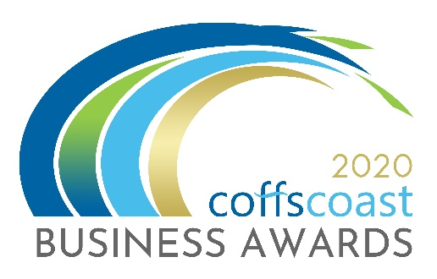
COFFS COAST BUSINESS AWARDS 2020
ENTRY FORM
Category – EXCELLENCE IN MICRO BUSINESS
- Aligned to NSW Business Chamber Awards

Business Details
To be completed by all entrants including those entering into the individual categories
- Trading name:

- Registered ABN:

- How is your business structured?
Choose from drop down list - Choose an item.

- Is your business classified as a not for profit?
Yes ☐ / No ☐

- Main office address:

- Business trading commencement date:

- What is the main industry your business operates in?
Choose from drop down list - Choose an item.

- Number of employees on the payroll in Australia.
Choose from drop down list - Choose an item.

- Is your business primarily business to business or business to consumer?
Choose from drop down list - Choose an item.

- Please provide a 100 word biography for your business to be used for promotional purposes.

- Please indicate the main reason/s you are entering into the Business Awards
- To raise the profile of my business
- To recognise my staff and our achievements
- To build business networks
- To reflect on the goals, strategies and vision that led to the success of your business and to use those insights to drive even greater success in the future.

- Website:
- Twitter:
- Instagram:
- LinkedIn:
- Facebook:

Contact Details:
To be completed by all entrants
Entry Contact Details:
First Name:
Surname:
Position:
Email:
Phone:
Mobile:

Media Contact Details
Tick box if same as above
First Name:
Surname:
Position:
Email:
Phone:
Mobile:

Business Performance – Not Compulsory – See Note Below.
It is recommended that this is completed by all entrants except those entering into the Outstanding Young Employee. For those businesses entering into the StartUp Superstar category you are only required to provide 12 months of financial data. This section will assist the judges in determining and benchmarking your business. The information provided remains confidential and will not be used for any other purpose than judging these business awards and the awards program itself.
- State your current assets and liabilities
Current Assets
(Cash and other assets that are expected to be converted to cash within the next financial year)
Current Liabilities
(Amounts due to be paid to creditors within the next financial year)

- Please provide the following figures for the last financial year and previous financial year.

Net Sales after the deduction of returns, allowance for damaged and missing goods and discounts for the current financial year
Operating Expenses incurred through normal business operations, excluding interest expenses.
- Net Profit After Tax and Interest Expenses
Please Note: For the Coffs Coast Business Awards, you do not need to complete the Business Performance section if you feel the information requested is too sensitive – In some of the questions it asks about financials – you do not have to list specific ‘numbers / $$ amounts, you can use percentages – graphs – etc. we do not need your “net” value.
However, this award is an aligned award with the NSWBC – you will most likely have to provide this information if you are successful in getting through to the regional awards; the NSW Business Chamber would then contact you to discuss in further detail if required.

Excellence in Micro Business
Description
The Excellence in Micro Business award recognises a business with less than 5 employees that has achieved significant growth (market share, sales volume, turnover, profitability) and is able to demonstrate the specific strategies and plans implemented to achieve sustainable growth in the previous financial year.

Award eligibility check box
- This business has been trading for a period of two years or more, not bankrupt or trading insolvent at the time of entry
- This business has less than 5 employees on the payroll in Australia
- This business has not entered into the Excellence in Social Enterprise category, Excellence in Small Business or Excellence in Business category.

Questions

- Provide an overview of the key features of your business plan including goals, strategies and outcomes. Maximum word count: 400

- Define your business product and/or service offering/s. Maximum word count: 400

- Define your target market/s. Maximum word count: 300

- What is unique about your business i.e. what makes it stand out from your competitors? Maximum word count: 300

- Do you have monthly reporting of financial performance (profit and loss, cash flow and other key performance indicators)? Specify reports. Maximum word count: 300

- Detail your business goals and key milestones achieved in the previous financial year. Maximum word count: 450

- What were the strategies and plans you initiated to achieve your business growth over the previous financial year? Maximum word count: 300

- Detail the key challenges and opportunities your business and industry face in the future. Maximum word count: 300

- What strategies or plans do you have in place to address these challenges and/or opportunities? Maximum word count: 450

- Demonstrate how your business contributes to the local economy in your region. For example employing local people, local purchasing etc. Maximum word count: 250

I declare that the information I have provided in this entry form is true and correct at the time of completing this form and that I agree to all conditions of entry listed under the “Conditions of Entry” section of the website. (www.coffscoastbusinessawards.com.au)

Once you complete this form you should save it on your computer using the file name EXCELLENCE IN MICRO BUSINESS. Then return to the Coffs Coast Business Awards Website www.coffscoastbusinessawards.com.au
- Go to the application upload section and follow the instructions.
- You will use your email account to upload your completed Entry Forms.
- You must also submit 4 high resolution landscape images in JPG format.
Video options:
To help you in making a video please see the video options section on the upload page
- ALL entries must submit a maximum 20 second video (in MP4 or MOV format). The video clip will be about your business, staff and tell your story as to your reasons for entering the category/s. The video clip and images will be used as part of a multimedia presentation on the awards night.
- For each category you enter – you must submit a different video clip about your business, staff and tell your story as to your reasons for entering the category.

