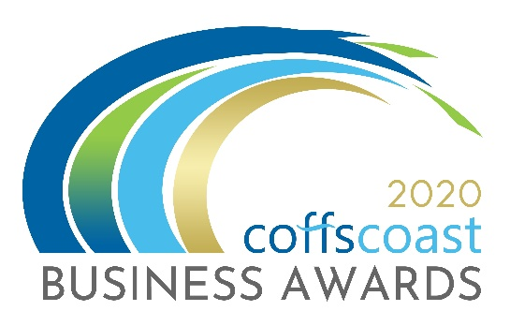
COFFS COAST BUSINESS AWARDS 2020
ENTRY FORM
Category – ACCOMMODATION, HOTELS, CLUBS AND BARS

Business Details
To be completed by all entrants including those entering into the individual categories
- Trading name:

- Registered ABN:

- How is your business structured?
Choose from drop down list - Choose an item.

- Is your business classified as a not for profit?
Yes ☐ / No ☐

- Main office address:

- Business trading commencement date:

- What industry does the business operate in?
Choose from drop down list - Choose an item.

- Number of employees on in Australia.
Choose from drop down list - Choose an item.

- Is your business primarily business to business or business to consumer?
Choose from drop down list - Choose an item.

- Please provide a 100 word biography for your business to be used for promotional purposes.

- Please indicate the main reason/s you are entering into the Business Awards
- To raise the profile of my business
- To recognise my staff and our achievements
- To build business networks
- To reflect on the goals, strategies and vision that led to the success of your business and to use those insights to drive even greater success in the future.

- Website:
- Twitter:
- Instagram:
- LinkedIn:
- Facebook

Contact Details:
To be completed by all entrants
Entry Contact Details:
First Name:
Surname:
Position:
Email:
Phone:
Mobile:

Media Contact Details
Tick box if same as above
First Name:
Position:
Email:
Phone:
Mobile:

ACCOMMODATION, HOTELS, CLUBS AND BARS
Description
This category is open to all businesses who are hotels, motels, farm stays, B&B, caravan parks, backpackers.

Questions:
- What tourism products, experiences and services do you offer visitors? Max word count: 400.

- Describe how you measure customer satisfaction and identify areas of improvement. Max word count: 400.

- Demonstrate how your business contributes to the local economy. Max Word count: 400.

- Describe the innovative marketing strategies you have implemented to encourage new and/or repeat business and demonstrate the success of these initiatives. Max word count: 400.

- What investment has been made in staff training and development and how has this improved the services provided to your guests/visitors? Max word count 400.

I declare that the information I have provided in this entry form is true and correct at the time of completing this form and that I agree to all conditions of entry listed under the “Conditions of Entry” section of the website. (www.coffscoastbusinessawards.com.au)

Once you complete this form you should save it on your computer using the file name ACCOMMODATION, HOTELS, CLUBS AND BARS. Then return to the Coffs Coast Business Awards Website www.coffscoastbusinessawards.com.au
- Go to the application upload section and follow the instructions.
- You will use your email account to upload your completed Entry Forms.
- You must also submit 4 high resolution landscape images in JPG format.
Video options:
To help you in making a video please see the video options section on the upload page
- ALL entries must submit a maximum 20 second video (in MP4 or MOV format). The video clip will be about your business, staff and tell your story as to your reasons for entering the category/s. The video clip and images will be seen by the judges and used as part of a multimedia presentation on the awards night.
- For each category you enter – you must submit a different video clip about your business, staff and tell your story as to your reasons for entering the category.

