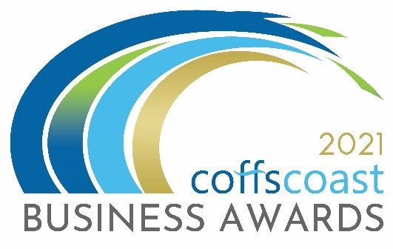
COFFS COAST BUSINESS AWARDS 2021
ENTRY FORM
Category – COVID-19 BUSINESS RESILIENCE

Business Details
To be completed by all entrants including those entering into the individual categories
- Trading name:

- Registered ABN:

- How is your business structured?
Choose from drop down list - Choose an item.

- Is your business classified as a not for profit?
Yes ☐ / No ☐

- Main office address:

- Business trading commencement date:

- What industry does the business operate in?
Choose from drop down list - Choose an item.

- Number of employees on in Australia.
Choose from drop down list - Choose an item.

- Is your business primarily business to business or business to consumer?
Choose from drop down list - Choose an item.

- Please provide a 100 word biography for your business to be used for promotional purposes.

- Please indicate the main reason/s you are entering into the Business Awards
- To raise the profile of my business
- To recognise my staff and our achievements
- To build business networks
- To reflect on the goals, strategies and vision that led to the success of your business and to use those insights to drive even greater success in the future.

- Website:
- Twitter:
- Instagram:
- LinkedIn:
- Facebook:

Contact Details:
To be completed by all entrants
Entry Contact Details:
First Name:
Surname:
Position:
Email:
Phone:
Mobile:

Media Contact Details
Tick box if same as above
First Name:
Position:
Email:
Phone:
Mobile:

COVID-19 Business Resilience Award
2020 has been a year of uncertainty, restrictions and changes with many businesses forced, through legislation or circumstance, to change their operating models, temporarily close their doors, or skilfully soldier on, doing their best to help support their community.

Business owners have thought outside the box, tightened their belts and acknowledged that now is not the time for “business as usual”. To applaud the resilience of local businesses the Coffs Coast Business Awards have introduced the ‘COVID-19 Business Resilience Award’ as a one-off category for 2021.

If you (or a business you know) have adapted and come out the other side of the COVID-19 crisis, we want to hear your story - whether you’re a large or small business, or a one-person operation trading from home, your achievement in these times is worthy of celebration.

Questions:

1. In no more than 100 words please provide a brief overview of the impacts of COVID-19 on your business.

2. Please detail in no more than 800 words a complete overview of:
- your response and timing to the impacts of COVID-19
- the strategic solutions and recovery actions planned by your business
- how you executed these actions and the results seen

3. What activities have you implemented to build resilience into your business and safeguard your business future? Max word count 300

4. What do you consider the one most important achievement you have made in the past 12 months through your business? Max word count 150

5. What did your business do during 2020 and the COVID-19 pandemic to ensure the physical and mental health and well-being of yourself, your staff, your customers and your community, ensuring productivity, information sharing and transition to the new normal planning? Max word count 300

I declare that the information I have provided in this entry form is true and correct at the time of completing this form and that I agree to all conditions of entry listed under the “Conditions of Entry” section of the website. www.coffscoastbusinessawards.com.au

Once you complete this form you should save it on your computer using the file name COVID-19 BUSINESS RESILIENCE AWARD
.Then return to the Coffs Coast Business Awards Website www.coffscoastbusinessawards.com.au
- Go to the application upload section and follow the instructions.
- You will use your email account to upload your completed Entry Forms.
- You must also submit 4 high resolution landscape images in JPG format.
Video options:
To help you in making a video please see the video options section on the upload page
- ALL entries must submit a maximum 20 second video (in MP4 or MOV format). The video clip will be about your business, staff and tell your story as to your reasons for entering the category/s. The video clip and images will be seen by the judges and used as part of a multimedia presentation on the awards night.
- For each category you enter – you must submit a different video clip about your business, staff and tell your story as to your reasons for entering the category.

