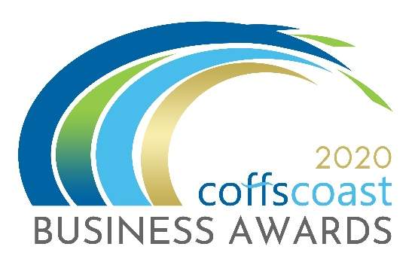
COFFS COAST BUSINESS AWARDS 2020
ENTRY FORM
Category – EXCELLENCE IN INNOVATION
- Aligned to NSW Business Chamber Awards

Business Details
To be completed by all entrants including those entering into the individual categories
- Trading name:

- Registered ABN:

- How is your business structured?
Choose from drop down list - Choose an item.

- Is your business classified as a not for profit?
Yes ☐ / No ☐

- Main office address:

- Business trading commencement date:

- What industry does the business operate in?
Choose from drop down list - Choose an item.

- Number of employees on payroll in Australia.
Choose from drop down list - Choose an item.

- Is your business primarily business to business or business to consumer?
Choose from drop down list - Choose an item.
- Please provide a 100 word biography for your business to be used for promotional purposes.

- Please indicate the main reason/s you are entering into the Business Awards
- To raise the profile of my business
- To recognise my staff and our achievements
- To build business networks
- To reflect on the goals, strategies and vision that led to the success of your business and to use those insights to drive even greater success in the future.

- Website:
- Twitter:
- Instagram:
- LinkedIn:
- Facebook:

Contact Details:
To be completed by all entrants
Entry Contact Details:
First Name:
Surname:
Position:
Email:
Phone:
Mobile:

Media Contact Details
Tick box if same as above
First Name:
Position:
Email:
Phone:
Mobile:

Business Performance – Not Compulsory – See Note Below.
It is recommended that this is completed by all entrants except those entering into the Outstanding Young Employee. For those businesses entering into the StartUp Superstar category you are only required to provide 12 months of financial data. This section will assist the judges in determining and benchmarking your business. The information provided remains confidential and will not be used for any other purpose than judging these business awards and the awards program itself.
- State your current assets and liabilities
Current Assets
(Cash and other assets that are expected to be converted to cash within the next financial year)
Current Liabilities
(Amounts due to be paid to creditors within the next financial year)

- Please provide the following figures for the last financial year and previous financial year.

Net Sales after the deduction of returns, allowance for damaged and missing goods and discounts for the current financial year
Operating Expenses incurred through normal business operations, excluding interest expenses.
- Net Profit After Tax and Interest Expenses

Please Note: For the Coffs Coast Business Awards, you do not need to complete the Business Performance section if you feel the information requested is too sensitive – In some of the questions it asks about financials – you do not have to list specific ‘numbers / $$ amounts, you can use percentages – graphs – etc. we do not need your “net” value.
However, this award is an aligned award with the NSWBC – you will most likely have to provide this information if you are successful in getting through to the regional awards; the NSW Business Chamber would then contact you to discuss in further detail if required.

Excellence in Innovation
Description
The Excellence in Innovation award recognises businesses that have made significant contributions to their industry through the introduction or improvement of an idea, method, technology, process or application.
Award eligibility check box
- This business has been trading for a continuous period of two years or more, not bankrupt or trading insolvent at the time of entry.

Questions
- Provide details of the innovation or innovative approach in your business. Maximum word count: 300

- Explain how your business monitors and reacts to changes in the market including how your business acquires an understanding of emerging customer needs and market developments. Maximum word count: 300

- How well has the innovation been received by the marketplace? Provide details of the cost effectiveness, integration, risk minimisation and commercialisation. Maximum word count: 300

- How has innovative activity in your business helped grow or improve your business such as increased size, greater scope, productivity improvements, higher revenue, and lower cost? Maximum word count: 400

- Demonstrate how the innovation has or is likely to have a positive impact beyond your business (i.e. to your industry, to the community). Maximum word count: 400

- How did this innovation achieve its objectives and goals? Maximum word count: 400

I declare that the information I have provided in this entry form is true and correct at the time of completing this form and that I agree to all conditions of entry listed under the “Conditions of Entry” section of the website. (www.coffscoastbusinessawards.com.au)

Once you complete this form you should save it on your computer using the file name EXCELLENCE IN INNOVATION. Then return to the Coffs Coast Business Awards Website www.coffscoastbusinessawards.com.au
- Go to the application upload section and follow the instructions.
- You will use your email account to upload your completed Entry Forms.
- You must also submit 4 high resolution landscape images in JPG format.
Video options:
To help you in making a video please see the video options section on the upload page
- ALL entries must submit a maximum 20 second video (in MP4 or MOV format). The video clip will be about your business, staff and tell your story as to your reasons for entering the category/s. The video clip and images will be seen by the judges and used as part of a multimedia presentation on the awards night.
- For each category you enter – you must submit a different video clip about your business, staff and tell your story as to your reasons for entering the category.

